JNN Template

Nanoarchitectonics for ............. (within 15 words)

Aust Ralia,1,2 Ja Pan,2,3 and Tai Wan3,*
1Department of Materials .......... Australia
2Institute of Photonics......., Japan
3Electronics and ..........., Taiwan

*Corresponding author: Name …………………, Email:…………………………

Author - Please insert Dates here
Submitted/Received: ……..…………. Accepted: ……...…….…

Abstract
Nanoarchitectonics is emerging concept .................... of polarity within bipolar resistive switching operation occurs in Pt/HfO2/TiN and Pt/Hf/HfO2/TiN resistive random access memory devices. This reversion of voltage polarity is the result of interface generation which induces a conduction mechanism transformation from Poole-Frenkel emission to space charge limited current mechanism. To prove the reversion of polarity, this study uses curve fitting of I-V relations to verify the conduction mechanism theoretically and physical analysis to verify the oxygen ion distribution practically. The proposed Pt/Hf/HfO2/TiN devices exhibit good resistive switching characteristics, such as good uniformity,low voltage operation, robust endurance (103 dc sweep), and long retention (3×104 s at 85 oC).
Keywords: HfO2, Resistive random access memory, Hf Metal Layer, polarity reversal.

**First Time Use of Abbreviations: No abbreviations are allowed in the title and abstract, therefore, all abbreviations should be defined the first time they are used within the title and text. For example, use first time as; Fourier transform infrared (FTIR) spectroscopy, scanning electron microscopy (SEM), transmission electron microscope (TEM), X-ray diffraction (XRD), X-ray photoelectron spectroscopy (XPS), Visible/near-infrared (Vis/NIR) spectroscopy, X‐ray absorption fine structure (EXAFS) spectroscopy, etc.

1. Introduction
Nanoarchitectonics has been paid much attention as an emerging concept [1-5]. Resistive random access memory (RRAM) devices achieve the memory effect using the switchable resistance transformation between a high resistance state (HRS) and a low resistance state (LRS), and typically consist of a metal/insulator/metal structure. RRAM devices generally have two switching modes (unipolar and bipolar), which alternate based on the operating voltage polarity. Unipolar resistive switching occurs in any single voltage bias and does not depend on voltage polarity. Conversely, bipolar resistive switching depends on the variation of voltage polarity to complete the set (i.e., from the HRS to the LRS) and reset (i.e., from the LRS to the HRS) processes. Recent developments in RRAM have shifted to bipolar RRAM for several advantages, including a stable ON/OFF ratio, robust endurance, good retention, smaller switching voltage fluctuation, and the one selector-one resistor (1S1R) application [6]. The transition metal oxide, HfO2, is already widely used in semiconductor industries because of its superior physical properties, such as large permittivity, subsequent band gap, and excellent thermal stability [7]. In addition to its use as high-k/metal gate stacks, HfO2-based RRAM has attracted significant attention for its potential in next-generation nonvolatile memory. HfO2-based RRAM devices are formed by an electric-field induced conductive filaments formation/rupture process, and possess superior bipolar resistive switching for future RRAM applications.
The localized ........

2. Experimental Details
In this study, RRAM devices consist of

3. Results and Discussion
Figures 1a and 1b show

4. Conclusion
Figures 1a and 1b show

Acknowledgments

References and Notes
Please use HARVARD Referencing Style from Google Scholar (https://scholar.google.com). All references should be listed in a proper Harvard style on a separate page, numbered in the sequence in which they occur in the text. Cite references numerically in a bracket [ x ] in the text and follow the same numerical order in the “Reference List” at the end of the manuscript. Do not use the phrases
"et al." or "ibid." in the reference list, instead, include names of all authors in a reference.

Authors could directly copy references in a Harvard style from the Google Scholar (https://scholar.google.com) and then paste in the Reference List of the manuscript as such.

EXAMPLES
- Journal Articles

[1] Komiyama, M.; Mori, T.; Ariga, K. 2018. Molecular imprinting: materials nanoarchitectonics with molecular information. Bulletin of the Chemical Society of Japan, 91(7), pp. 1075-1111.
[2] Azhar, A.; Li, Y.; Cai, Z.; Zakaria, M.B.; Masud, M.K.; Hossain, M.S.A.; Kim, J.; Zhang, W.; Na, J.; Yamauchi, Y.; Hu, M. 2019. Nanoarchitectonics: a new materials horizon for Prussian blue and its analogues. Bulletin of the Chemical Society of Japan, 92(4), pp. 875-904.
[3] Zhao, L.; Zou, Q.; Yan, X. 2019. Self-assembling peptide-based nanoarchitectonics. Bulletin of the Chemical Society of Japan, 92(1), pp. 70-79.
[4] Ariga, K.; Mori, T. ; Li, J. 2019. Langmuir nanoarchitectonics from basic to frontier. Langmuir, 35(10), pp. 3585-3599.
[5] Ariga, K.; Nishikawa, M.; Mori, T.; Takeya, J.; Shrestha, L.K.; Hill, J.P. 2019. Self-assembly as a key player for materials nanoarchitectonics. Science and Technology of Advanced Materials, 20(1), pp. 51-95.

Book
Nalwa, H.S. and Miyata, S., eds., 1996. Nonlinear Optics of Organic Molecules and Polymers. Boca Raton, CRC Press.

Book Chapter
Krill, C.E., Harberkorn, R. and Birringer, R., 1999. in Handbook of Nanostructured Materials and Nanotechnology, edited by H. S. Nalwa, Academic Press, Vol. 2, pp.155-211.

Website
National Renewable Energy Laboratory (NREL) (https://www.nrel.gov/solar)

Conference Proceedings
Kimura, J. and Shibasaki, H., eds., (1995). Recent Advances in Clinical Neurophysiology. Proceedings of the 10th International Congress of EMG and Clinical Neurophysiology, October 15-19; Kyoto, Japan. pp.10-15.

ALL FIGURES IN VERY HIGH QUALITY REQUIRED
Important Note – Poor/blurred quality figures will not be accepted at all. There are
no charges for color figures whatsoever so please make all figures in COLORS for a better presentation. It is very important to use Large Fonts (size) for Numbering and Ligands in all figures as shown below.

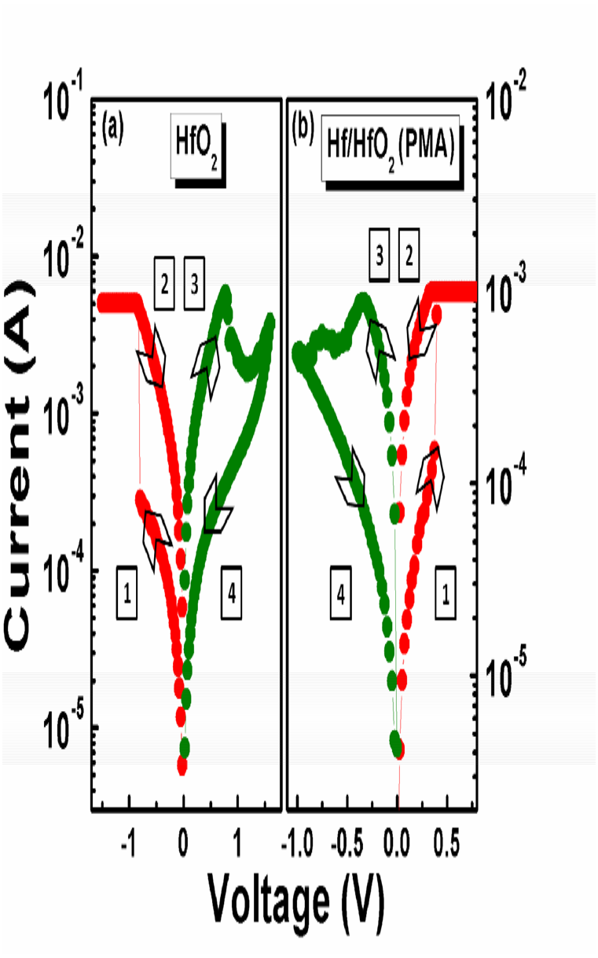
Figure 1. Reverse polarity operation in resistive switching between Pt/HfO2/TiN and Pt/Hf/HfO2/TiN devices.

Graphical Abstract
The reversion of polarity within bipolar resistive switching operation occurs in Pt/HfO2/TiN and Pt/Hf/HfO2/TiN resistive random access memory devices. The proposed Pt/Hf/HfO2/TiN devices exhibit good resistive switching characteristics, such as good uniformity, low voltage operation, robust endurance (103 dc sweep), and long retention (3×104 s at 85 oC).

